Aberystwyth University Students’ Union
Room Capacities and Layout Options

 |  | Main Room | Picture House | Cwtch Bar | Committee Room | Meeting Room
Room layout | Theatre | 200 | 95 | 100* | 50 | -
 | Classroom | 84 | 32 | 28 | 24 | -
 | Cabaret | 152 | 72 | 136 | - | -
 | Boardroom | 36 | 36 | 36 | 12 | 8
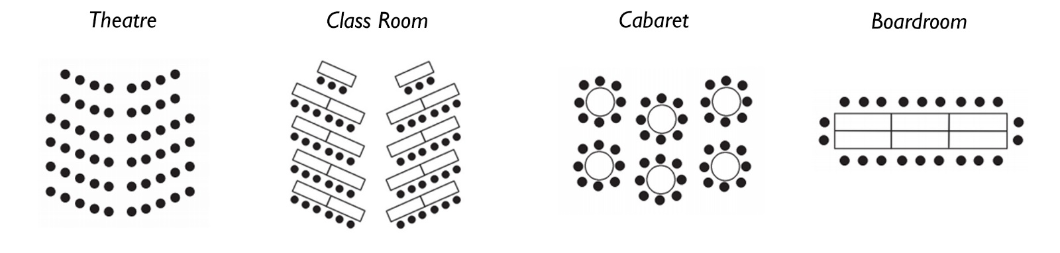
*With cleared raised area

